**Automation Technical Test**

**Purpose**

As part of our hiring process for technical roles, we require all candidates to complete a small technical exercise. This is an integral part of our process to assess an individual’s technical ability when completing an activity in their own time.

Given the importance of this exercise to our hiring process, we highly recommend you give this adequate consideration and address this task as you would do any other professional assignment in your current/previous workplace.

**Instructions**

* There are two parts to this technical assessment
  + A written assessment of your ability to tackle a typical testing problem you might face as a Sr. test analyst/engineer
  + A code-based assessment, testing your ability to automate a test scenario
* Written answers for part 1 should be submitted in a suitable format - e.g. a word document
* Please work on a GitHub, create the New branch within this repository and when you are happy to submit, create a pull request back into the main branch
* Please use the pull request to comment on any aspects of your solution that you didn’t have time to complete, are not complete to your satisfaction or are not working
* Would you please add a markdown file with instructions on how to set up and run your solution to question 2

**Question 1**

**Introduction**

The following is the main form of an application that converts values from one currency to another. The application has the following characteristics:

* The collection of currencies, exchange rates, and rules for applying commission are held in a shared database, accessed by multiple users of this application on a network.
* The user of this form selects a base currency, a target currency, specifies an amount (expressed in the base currency), can choose to include or exclude commission, and then hits the Convert button to generate the equivalent value in the target currency. The screenshot below shows that value where “N/A” is displayed.
* The separate “Maintain currencies” form (not shown) provides operations for adding, deleting and editing currencies.
* A separate process constantly updates the database with exchange rates for any recognised currencies (you do not need to worry about how this works, but you do have control over stopping and starting it).
* The separate “Maintain commission rates” form (not shown) provides operations for specifying a minimum commission value and a collection of commission rates for different ranges of values. The minimum commission value and ranges are defined in Sterling. For example, for “amount to convert” values in the range of 0.01 to 100.00 pounds Sterling, the commission rate is 5%. An example minimum commission value is £10.

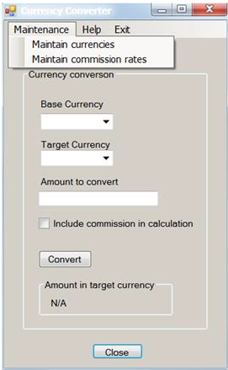

Given the information provided, please answer the following questions:

1. Using the database and the GUI, how would you test the functionality of this form?

First check the happy path with different scenarios :   
 -> By perfom giving all required details and click on convert

-> Another by without “commission in calculation”

Negative scenario:

* + Without select the Base currency click on convert
  + Without select the Target currency click on convert

1. What tests would you perform to test the operations supported by the “Maintain currencies” form?
   * Add one record using add option
   * Add multiple records using add option and verify how it perform
   * Edit the existing records
   * Click on edit and don’t edit any data and click on save
   * Try the delete option and check whether the particular record was deleted.
2. What tests would you perform to test the operations supported by the “Maintain commission rates” form?
   * Check the Maintain commission rates in the acceptance criteria and make sure the rates are same.
3. What tests would you perform on the form above to test accessibility?
   * Perform accessibility testing based on text present in the application.
   * And using the mouse and keyboard actions.
   * Try perfom in different viewports
   * Will use “Cypress Axe” options to make sure the accessibility is working has expected.
4. If you were automating the testing of this form for regression test purposes, what would you hope the developer had done to make the automation easier?
   * Check the Locators / Identifiers of the application.
   * Verify the application is stable for automation.
   * Which technology was used for development.
   * Number of scenarios need to automate for regression.
5. If this application were used internationally, what further tests would you perform?
   * Use browserstack to test the application from different countries on the real devices.
6. The screenshot of the form above shows immediately apparent user interface issues (you may have mentioned some of these in previous answers)?
   * Look of the application need to improve.
   * Need to perform actual testing on the application to find user interface issues

**Notes**

* In answering the questions, identifying tests is sufficient
* Details of test data and expected results are not required where they can be inferred
* Aim for an answer no longer than 1200 words for this entire section

**Question 2**

**Introduction**

For this question, you can use any C#/JavaScript framework of your choice. We want you to automate the scenarios below using the Chrome browser.

**Test Scenario**

1. Open the following URL: <https://www.moneycorp.com/en-gb/> and verify
2. Change the language and region from the top right corner to USA (English) and verify See example snippet.

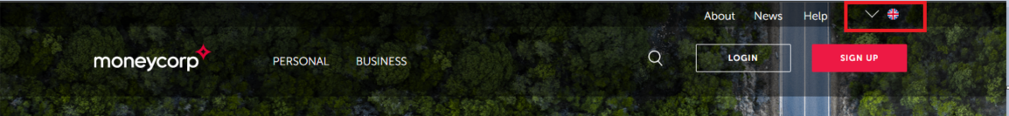

1. Click Find out more for “Foreign exchange solutions” Validate if you have arrived on the page
2. Search for the word “international payments” using the search box
3. Validate if you have arrived on the result page
4. Validate that each article in the list displays a link that starts with <https://www.moneycorp.com/en-us/>

**Question 3**

**Introduction**

The following is a simple API that suggests tasks based on parameters passed in, <https://www.boredapi.com/>

Generate three activities for two people that have a type social and assert that the results are appropriate.

Please write tests using the C# framework.

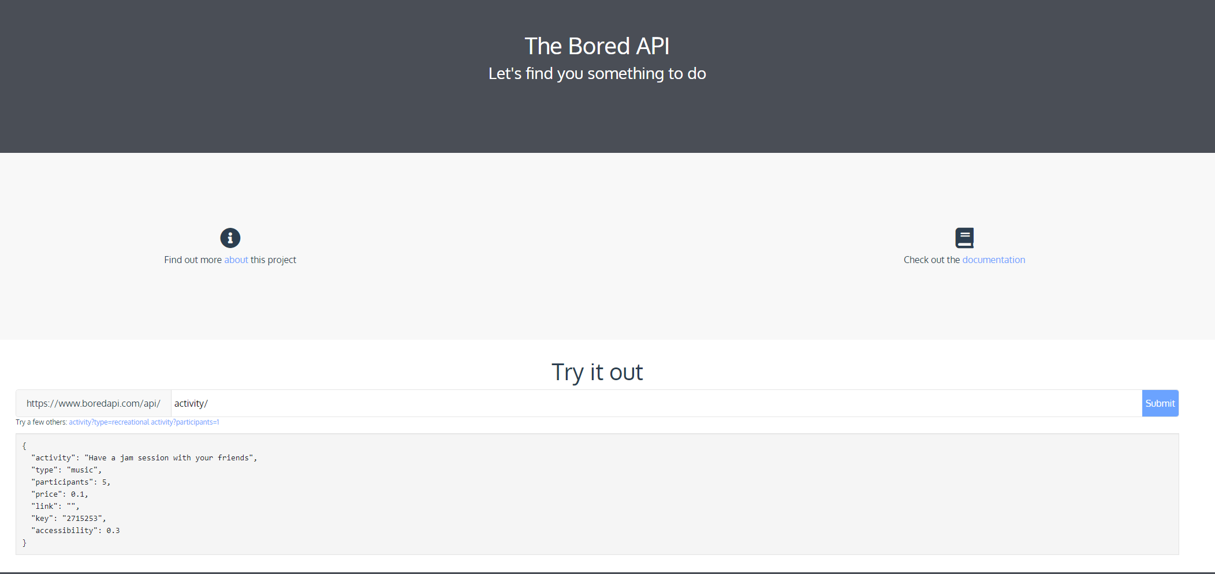

**Evaluation**

Evaluation will be done on the following criteria:

* Clean and tidiness of the solution
* Design and architecture
* Readability
* Maintainability
* Stability of the tests
* Clarity of setup and execution documentation

Please provide instructions for setting up an environment from scratch and how to run the tests.